Regional Healthcare Partnerships 8 and 17
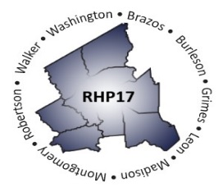
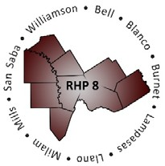
Joint Managed Care Forum and Learning Collaborative
sponsored by
Seton Highland Lakes

Thursday, March 24, 2016, 9:00 a.m. – 3:00 p.m.
Texas A&M Health Science Center - Round Rock Auditorium

AGENDA

Joint Managed Care Forum, 9:00 a.m. – 11:15 a.m.

Registration/Networking

Welcome and Introduction
RHP 17 Anchor Team

Presentation: Importance of and Considerations for Improved Alignment between DSRIP and Managed Care
Emily Sentilles, Program Specialist
Texas Health and Human Services Commission

Forum Focus: Overview of Regional Programs
RHP 8 and RHP 17 Program Providers
(Facilitated by RHP 17 Anchor Team)

Forum Q&A: Open Discussion between MCOs and Participants
Facilitator: RHP 17 Anchor Team

Closing Remarks

Emily Sentilles
Program Specialist

Emily Sentilles is a program specialist with the Transformation Waiver Team in the Medicaid and CHIP Division of the Health and Human Services Commission.

Emily’s work on the DSRIP Waiver Team is split between the technicalities of DSRIP operations and working to foster collaboration between DSRIP projects and MCOs, with a focus on moving toward value-based purchasing arrangements.

Her prior work experience includes positions as a budget analyst with the Legislative Budget Board and a high school history teacher in Dallas. Emily holds a Bachelor of Arts degree in History from Brown University and a Master of Public Affairs from the LBJ School of Public Affairs at The University of Texas at Austin.


Regional Healthcare Partnerships 8 and 17
Joint Managed Care Forum and Learning Collaborative
sponsored by
Seton Highland Lakes

Thursday, March 24, 2016, 9:00 a.m. – 3:00 p.m.
Texas A&M Health Science Center - Round Rock Auditorium

AGENDA

Joint Learning Collaborative, 11:30 a.m. – 3:00 p.m.

Registration/Networking Lunch

Purpose and Goals of Event
RHP 8 Anchor Team

Presentation: Project Sustainability and Future of Waiver Renewal
John M. Scott, Director, Healthcare Transformation Waiver Operations, HHSC

Presentation and Activity: Sustainability Planning Process and Completion of Program Assessment Sustainability Tool
Jennifer LoGalbo, RHP 8 Program Director

Group Discussion/Networking
RHP 8 and RHP 17 Stakeholders
(Facilitated by RHP 8 Anchor Team)

Open Discussion
Facilitator: RHP 8 Anchor Team

Closing Remarks and Adjourn
RHP 8 Anchor Team

John Scott
Director

John Scott is Director of Operations for the Texas Healthcare Transformation Waiver at the Health and Human Services Commission. He holds a master's degree from the LBJ School of Public Affairs at the University of Texas at Austin.

Prior to joining HHSC in 2013, he worked in various capacities at the Department of State Health Services (formerly the Texas Department of Health) for 18 years, including seven years working closely with agency executives on strategic planning and implementation of high-priority projects.

He is also a certified Project Management Professional and a former yoga teacher.


